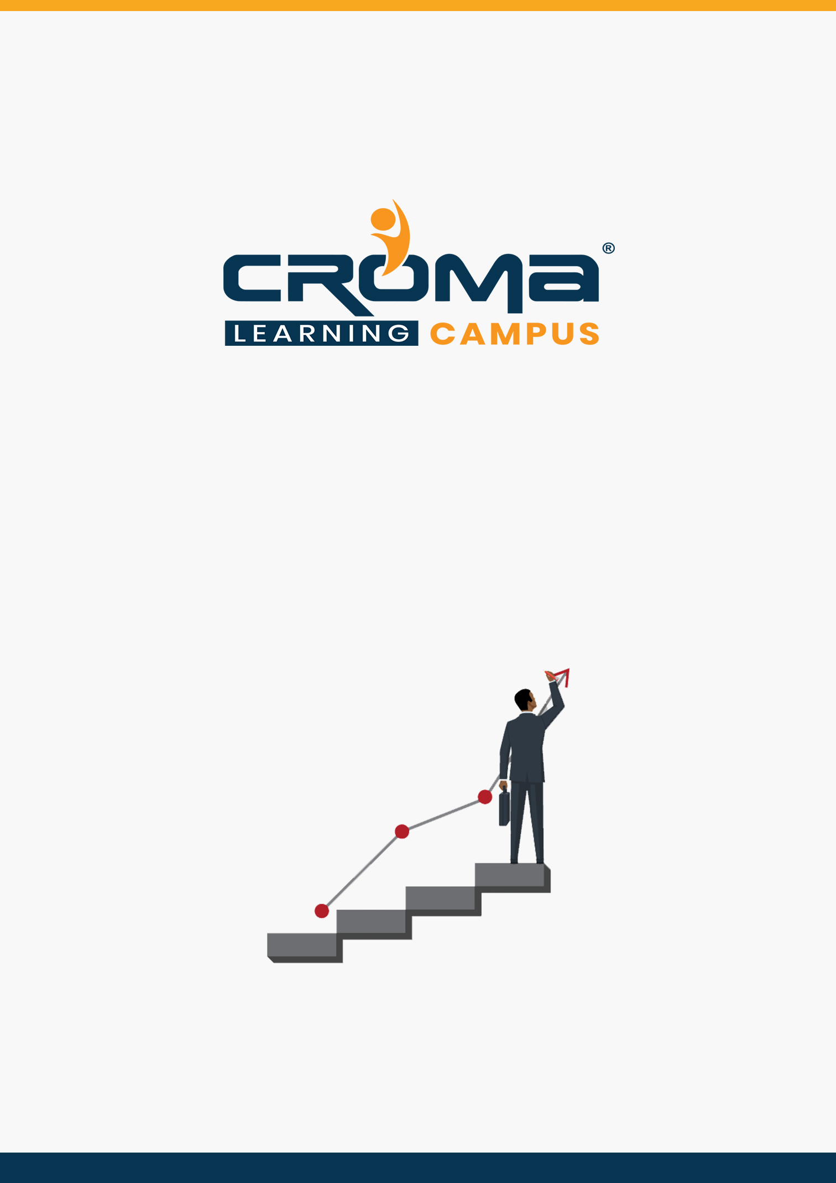

**AWS Cloud Developer Associate Training Curriculum**

**STRUCTURE**

**www.cromacampus.com | helpdesk@cromacampus.com | +91-120-4155255**

**AWS Cloud Developer Associate Training Curriculum**

*“Become a AWS Certified Cloud Developer by joining our comprehensive Training Program”*

**About Croma Campus:**

Croma Campus Training & Development Private Limited is an education platform since 2010 providing rigorous industry-relevant programs designed and delivered in collaboration with world-class faculty and industry.

* Hands-On Live Projects
* Simulation Test Papers
* Industry Cases Studies
* 61,640+ Satisfied Learners
* 140+ Training Courses
* 100% Certification Passing Rate
* Live Instructor Classroom / Online Training
* 100% Placement Assistance

Course Objectives:

* Understand the core concepts of AWS Cloud
* Leverage AWS developer tools to deploy your applications
* Rich hands-on labs to understand concepts better
* Understand and create VPC and auto-scaling
* Ability to deploy and operate EC2, EBS and ELB service
* Ability to create IAM users, groups, policies and roles
* DynamoDB – No SQL database use case

**Course Description:**

The course is designed based on official certification requirements outlined by AWS Cloud provider for AWS Certified Developer – Associate. After this course, you will be able to appear for the certification exam, “AWS Certified Developer – Associate”. The exam fee is 150 USD with Single attempts at an additional cost.

* Gives an edge over other professionals in the same field, in term of pay package.
* All roads are leading to Cloud, and everyone is adopting Cloud computing. Hence, would require Cloud Engineers to drive their journey to cloud
* Helpful for People are trying to transition to Cloud Engineer roles
* Verifies that you are aware of the latest features of Cloud
* The certification helps to speak more confidently about this technology at my company when networking with others.

Certification Details:

* Format: Multiple choice, multiple answer
* Type: Associate/Practitioner
* Delivery Method: Testing center or online proctored exam
* Time: 130 minutes to complete the exam
* Cost: 150 USD (Practice exam: 20 USD)
* Language: Available in English, Japanese, Korean, and Simplified Chinese

**Croma Campus Training Program Deliverables:**

* **Session Recordings** - Original Class Room Voice & Video Recording
* **Training Material** - Soft Copy Handbooks
* **Assignments** | 25+ Hands-on Exercises
* **Test Papers** - We provide **Practice Test** as part of our course to help you prepare for the actual certification exam.
* **Live Case Studies**
* **Live Projects** - Hands-on exercises and Project work. You will work on real time industry-oriented projects and assignments for each module to practice.
* **Key focus on Hands-on exercises and Project work**. You will work on real time industry-oriented projects.
* Faculty with more than **10+ Years of Experience** in the Industry.
* **Technical Resume Designing & Job Assistance:** With more than 100+ Clients across the Globe and we help learners to get a good job in their respective field. We also help learners with resume preparation.
* **Interview Q&A**
* **About Croma Campus Training Certificate:** Croma Campus will provide you with an industry-recognized (Certified by **ISO 9001:2015** & **E-Cell IIT Jodhpur**) course completion certificate which has lifelong validity.
* **How I Unlock my Croma Campus Certificate:** Attend Complete Batch & Submit at least One Completed Project.

Course Content:

Module 1: AWS Fundamentals

* Overview
* User Sign Up
* Overview Amazon Management Console
* Management Activity and Billing overview
* Amazon Pricing

Module 2: AWS Big Picture

* An Overview of AWS
* EC2- An overview
* EBS- An Overview
* Security Group-An Overview
* Elastic IP- An overview
* Cloud Front-An Overview
* S3- An overview
* Glacier- An overview
* IAM – An Overview
* RDS- AN overview

Module 3: Amazon EC2- Win Server 2012

* Launch Windows server 2012 Instance
* Decrypt Password and download RDP shortcut client
* Connect to the EC2 Windows 2012 instance
* Terminate the Windows server 2012 Instance

Module 4: Amazon EC2- Security Groups

* Creating Security Groups
* Modify Security Groups
* Delete Security Groups

Module 5: Amazon Elastic Block Store

* Create Standard Volume
* Create and delete snapshots
* Create Provisioned I/o Volume
* Assign volumes to Windows server 2012 and Ubuntu 14.04 server
* Disassociate and Delete volumes

Module 6: Amazon Elastic Load Balancing (ELB)

* Launch Two Ubuntu EC2 Instances- apache web servers with user data
* Edit HTML files to both the servers
* Test your web Servers through internet
* Create Elastic Load Balancer
* Add both the Ubuntu servers to ELB
* Test your Elastic Load Balancer
* Delete your Elastic Load Balancer

Module 7: AWS Route53

* What is Route53
* Route-53 demo integration with ELB you created

Module 8: AWS S3

* AWS S3- Overview and pricing
* Create Bucket and Folder
* Upload, download, share and delete object
* Delete Bucket

**Module 9: Amazon EC2- Ubuntu 14.04 with user data and metadata**

* Launch the EC2 Ubuntu cloud server
* Using User-data of web-server
* Validate user data is executed successfully
* Fetch information about VM from metadata URL

**Module 10: Amazon EC2 and EBS System operations**

* EC2- Advanced theory ec2 EBS vs instance store
* EC2- Operations (Status checks)
* EC2 – Creating your own AMI
* EC2 – Launching instance using own AMI
* EC2 – copy snapshot across region and share across accounts
* EBS – Snapshot
* EBS- creating volume using snapshot
* EBS – copy EBS snapshot across region and share across accounts
* EBS - upgrade volume types
* Security groups - create, edit and modify rules

**Module 11: AWS Elastic File System**

* AWS elastic File System – Overview and pricing
* Create EFS share and mount to an ec2 instance
* Store and retrieve from EFS

**Module 12: AWS S3**

* AWS S3- Overview and pricing
* Create Bucket and Folder
* Upload, download, share and delete object
* Delete Bucket
* File Versioning (S3 version control)
* Create a static website on s3
* Create a server less webpage
* Cross Region replication
* CORS configuration
* S3 Life cycle management
* S3 security and encryption

**Module 13: AWS Cloud Front**

* Cloud Front overview and pricing
* Create an origin bucket for Cloud Front
* Upload file to origin bucket
* Create CDN distribution and use origin bucket
* Access files through Cloud Front distribution

**Module 14: AWS other storage options**

* Storage Gateway – Overview and pricing
* Snowball – Overview and Pricing
* Glacier – Overview and pricing
* Glacier – Live demo by instructor using fast glacier client

**Module 15: AWS - IAM (Identity and Access Management)**

* What is IAM? – A comprehensive introduction
* AWS federation with Active directory- Theory only
* Web Identity Federation - Theory Only
* Security Token Service – Theory only
* Getting started with IAM
* IAM user- groups
  + Creating a user and group
  + Adding a user to the group
  + Password policy setup for users
  + Attaching policy to users
  + Enabling dual /Multifactor authentication to the users
* IAM roles (Hands on lab by students)
  + Creating a role
  + Launching a EC2 instance using a S3 full access role
  + Deleting a role

**Module 16: AWS CLI**

* Working with the AWS CLI
* Launch instance with s3 and ec2 full access
* Configure AWS cli client
* Create a security group using cli
* Create a key pair using cli
* Launch an ec2 instance using cli
* Stop an ec2 instance using cli
* Terminate an ec2 instance using cli
* Create an s3 bucket using cli
* Upload and download an object from your local machine to s3 through cli
* List buckets through cli
* Delete buckets through cli

**Module 17: AWS DynamoDB Database using Python SDK**

* AWS Database options: RDS and DynamoDB DB differences
* Describe Amazon DynamoDB
* DynamoDB Provisioned throughput
* Sung web identity to connect to authenticate with DynamoDB - Overview
* DynamoDB Indexes
* Aspects of DynamoDB
* Lab: Configure python SDK to access to DynamoDB
* Create tables using python SDK
* Put item in using SDK
* Scan and Query API call using python SDK
* Delete item using SDK

**Module 18: AWS Route 53**

* Route 53 - routing options
* Simple routing – Hand-on lab
* weighted routing policy lab
* latency based routing lab
* Geolocation based routing lab
* Failover routing lab

**Module 19: AWS- Virtual Private Cloud (VPC)**

* What is VPC? – A comprehensive introduction
* Networking bottlenecks
* Understanding VPC configurations
  + VPC with single public subnet
  + VPC with public and private subnet
  + VPC Peering
  + Access control List
* Configuring VPC Instances (Hands on lab by students)
  + Creating a VPC
  + Subnets
  + Internet Gateway
  + Routing
  + Configuring a NAT Gateway
  + Creating security groups
  + Launching instances in public and private subnets
* NAT vs Bastions
* VPC Flow Logs
* VPC clean up

**Module 20: AWS Cloud Formation**

* Infrastructure as Code using Cloud Formation
* Cloud formation – Create a new stack
* Create and deploy sample template in JSON format
* Use existing templates and deploy

**Module 21: Compute Part II operations**

* Bash Scripting
* Lambda

**Module 22: Application Development and Deployment Best Practices**

* Application deployment using AWS Elastic Beanstalk
* Deploy java beanstalk environment
* Deploy web application to environment
* Terminate beanstalk environment

**Module 23: AWS - Simple Notification Service (SNS)**

* Simple Notification Service (SNS) – Overview and use case
* Create SNS notification
* Subscribe for notification

**Module 24: AWS- SQS and SWF (Theory only)**

* Simple Queue Service (SQS) – Overview and use case
* Simple Workflow (SWF) - Overview and use case

**Module 25: Placement Guide**

* Tips to clear an Interview
* Common Interview questions and answers
* AWS Cloud Sysops Interview Questions and Answers
* Resume Building Guide
* Attempt for AWS Cloud Sysops Associate Global Certification Exam
* Earn Credentials and Start applying for Jobs